8. Check Iwconfig/ifconfig to understand in detail about network interfaces (check about Interface speed, MTU and other parameters)

**iwconfig - to display and configure wireless network interfaces**

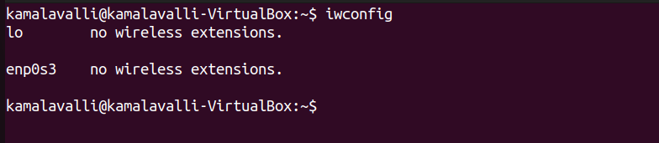

**ifconfig**

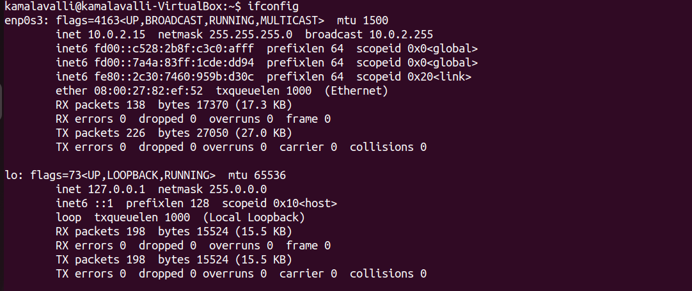

Params:

* **Flags (UP, BROADCAST, RUNNING, MULTICAST)** – Interface is active and supports broadcast & multicast.
* **MTU (1500)** – Maximum Transmission Unit (max packet size).
* **IPv4 Address (inet 10.0.2.15)** – Assigned IP address for network communication.
* **Subnet Mask (netmask 255.255.255.0)** – Defines the local network range (10.0.2.x).
* **Broadcast Address (broadcast 10.0.2.255)** – Used for sending packets to all devices in the subnet.
* **IPv6 Address (inet6 fd00::c528:2b8f:c3c0:afff)** – IPv6 address assigned to the interface.
* **MAC Address (ether 00:00:27:82:ef:52)** – Unique hardware identifier for the network adapter.
* **Transmit Queue Length (txqueuelen 1000)** – Number of packets that can be queued before sending.
* **Received Packets (RX packets 138)** – Total number of packets received successfully.
* **Received Data (RX bytes 17370 (17.3 KB))** – Total amount of data received.
* **Transmitted Packets (TX packets 226)** – Total number of packets sent successfully.
* **Transmitted Data (TX bytes 27050 (27.0 KB))** – Total amount of data transmitted.
* **Errors, Dropped Packets, Overruns, Collisions (0)** – No network transmission issues detected.
* **Loopback Interface (lo)** – Used for internal communication within the system (127.0.0.1).
* **Loopback MTU (65536)** – Higher MTU for internal data transfer.
* **Loopback Packets (RX/TX packets 198)** – Number of packets processed internally.
* **Loopback Data (RX/TX bytes 15524 (15.5 KB))** – Amount of data transferred internally.